
A
Grand Project On
VEIL
Submitted to
Gujarat University
Faculty of Computer Applications
In partial fulfilment of the requirement of the award for the degree of
Bachelor of Computer Application

Gujarat University
Submitted by
Name | Enrolment no.
Riya Modi | 202312101912
Riya Gevariya | 202312101849

1. COLLEGE CERTIFICATE

2. ACKNOWLEDGEMENT

“The success of any person is not only his hard work, but it is also the support and co-operation one gets for success.”
Apart from individual effort, the success of any project largely depends on the encouragement and guidance of many others. We take this opportunity to express our sincere gratitude to all those who have been instrumental in the successful completion of this project.
We express our deep gratitude to everyone who gave their valuable time by filling out our survey and helping us complete this project successfully. We would also like to thank the Principal I/C for providing a peaceful and supportive environment for our studies and for helping us in preparing this report.
We are especially grateful Faculty of Asia Pacific BCA College, for their valuable guidance, suggestions, and continuous support throughout the completion of this project.
Finally, we express our gratitude to Asia Pacific BCA College for the support and the positive environment it has provided.

3. INDEX PAGE

No. | Section | Page
1 | College Certificate | 2
2 | Acknowledgement | 3
3 | Index Page | 4
4 | Introduction | 5
5 | Dataset Selection | 6
6 | Data Preprocessing | 7
7 | Exploratory Data Analysis (EDA) | 8
8 | Visualization using Matplotlib and Seaborn | 9
9 | Model Evaluation and Performance Metrics | 10
10 | Model Building | 11
11 | Advanced Techniques and Pattern Discovery | 12
12 | Conclusion & Future Work | 13
13 | Bibliography | 14

4. INTRODUCTION

4.1 Problem Definition
Phishing is a form of social engineering in which an attacker attempts to deceive a person into revealing sensitive information, opening unsafe content or visiting a fraudulent website. Such attempts may be delivered through website URLs, email messages and SMS messages.
VEIL studies whether machine-learning methods can classify inputs as legitimate or suspicious using information from these three channels. URL records contain structured website features, whereas email and SMS records are mainly text. Therefore, the project uses two data groups: a URL dataset and a combined email/SMS dataset, with separate preprocessing pipelines.

4.2 Objectives of the Project
- Study phishing-related signals in URLs, emails and SMS messages.
- Prepare and analyse URL data separately from combined email/SMS text data.
- Perform preprocessing, EDA and visualization using Python libraries.
- Train and compare three supervised classification algorithms.
- Evaluate models using suitable classification metrics and confusion matrices.
- Implement at least one advanced technique: K-Means, DBSCAN or Apriori.
- Interpret results and document limitations and future improvements.

4.3 Scope
VEIL is an academic prototype, not a production security service. The URL and email/SMS models are evaluated separately because their features and potentially their label definitions differ. SMS spam must not be described as confirmed phishing unless the dataset labels support that interpretation.

5. DATASET SELECTION

The course guideline requires real datasets from sources such as Kaggle or the UCI Machine Learning Repository. Record the exact source, licence, access date, number of samples, feature columns and target variable for every dataset actually used.

5.1 Dataset Group A — URL

The available URL workbook was supplied for this project. A prepared export named VEIL_URL_Dataset.xlsx has 11,590 rows, including 160 resampled duplicate observations; these are not 160 new independent records. The original cleaned workbook was previously observed with 11,430 rows. Verify the final file, unique count, provenance and target before submission.

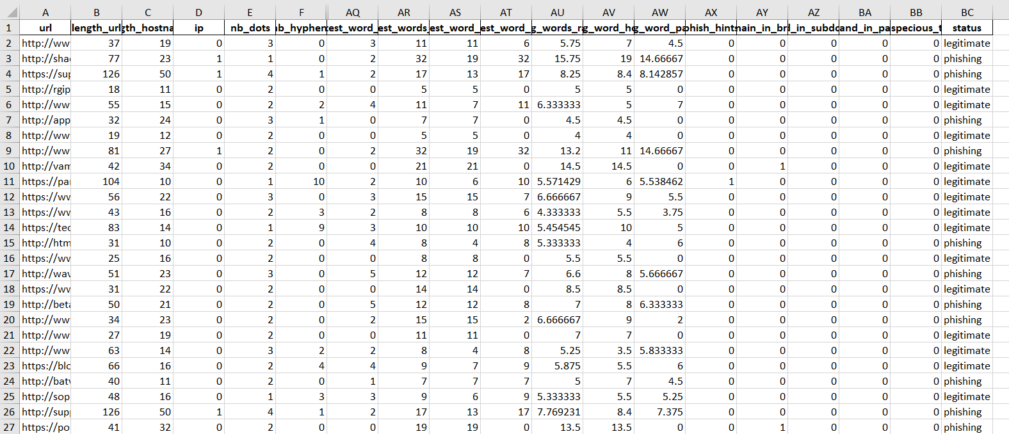

5.2 Dataset Group B — Combined Email and SMS

The current VEIL_Email_SMS_Mixed.xlsx file contains 23,180 AI-generated synthetic demonstration records (11,590 email and 11,590 SMS). These are not Kaggle/UCI records and do not meet the real-dataset requirement. The SMS label spam_unverified is not the same as confirmed phishing.

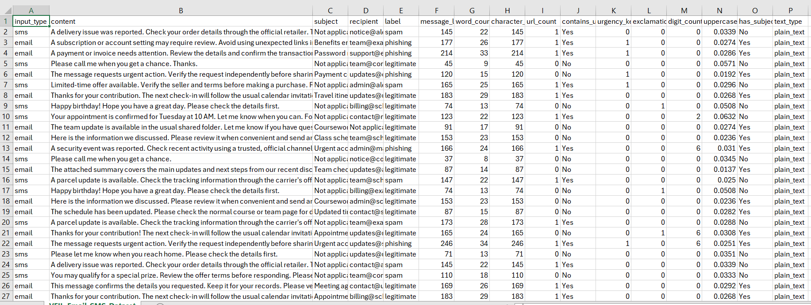

6. DATA PREPROCESSING

6.1 URL Data

- Load the verified final file; inspect dimensions, columns and data types.
- Check missing values, exact duplicates, duplicate URLs and constant columns.
- Verify feature definitions; remove identifiers and any target-leakage columns.
- Encode target labels consistently; split into training and testing sets.
- Scale numerical features for scale-sensitive models using a training-only pipeline.

6.2 Email/SMS Text Data

- Use verified public email and SMS data in final experiments.
- Keep input type to distinguish email from SMS; create a documented common text field.
- Handle structural blanks separately from true missing values.
- Normalize and tokenize text; transform it using a documented method such as TF-IDF.
- Preserve original labels; do not silently convert spam into phishing.

6.3 Split and Leakage Prevention

Split the data before fitting imputers, scalers, vectorizers or feature-selection steps. Fit transformations only on training data, preferably through Scikit-learn Pipelines. Where repeated templates or duplicate records exist, consider group-aware splitting to reduce leakage.

7. EXPLORATORY DATA ANALYSIS (EDA)

7.1 Univariate Analysis
Examine one variable at a time. For URL data, inspect target-class frequencies and distributions of numerical and categorical features. For email/SMS data, inspect input_type, labels, message length, word count and URL count.

7.2 Bivariate Analysis
Examine relationships between pairs of variables, such as URL feature versus target, message length versus label, or input_type versus label.

7.3 Statistical Summary
Report count, mean, standard deviation, minimum, quartiles and maximum for suitable numerical features. Include class frequencies for categorical variables.

7.4 Correlation Analysis
Calculate correlations for suitable numerical features and explain the method used. Correlation does not prove causation. For high-dimensional text vectors, use a suitable feature-level analysis instead of an unreadable full matrix.

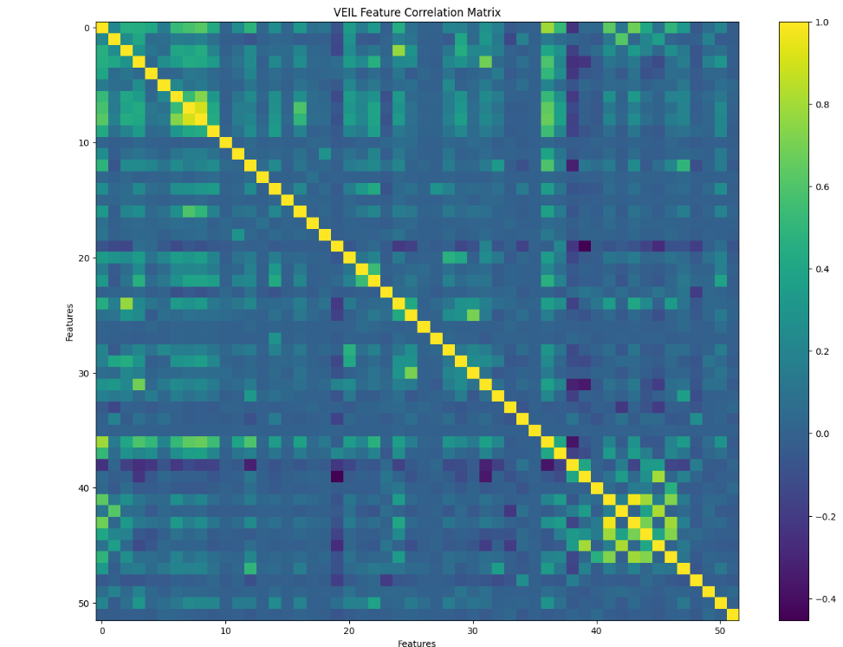

8. VISUALIZATION USING MATPLOTLIB AND SEABORN

Use Matplotlib and Seaborn to create readable figures. Each figure should include a figure number, descriptive title, axis labels, legend where needed and a short interpretation.
- Class distribution plot for the URL dataset.
- Histograms or boxplots for selected numerical URL features.
- Email/SMS input-type and label distribution plot.
- Message length or word-count comparison by class.
- Correlation heatmap for appropriate numerical features.
- Confusion-matrix heatmaps for the trained classifiers.
- Cluster or pattern visualization for the advanced technique.

MATPLOTLIB DIAGRAMS

1.Pie Chart – EMAIL-SMS
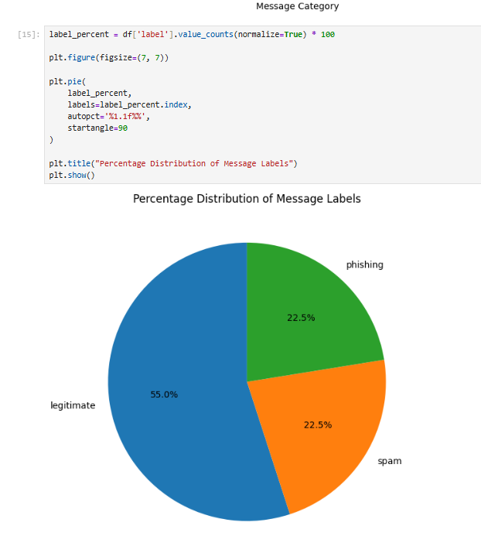

SEABORN DIAGRAMS

- BOXPLOT- URL

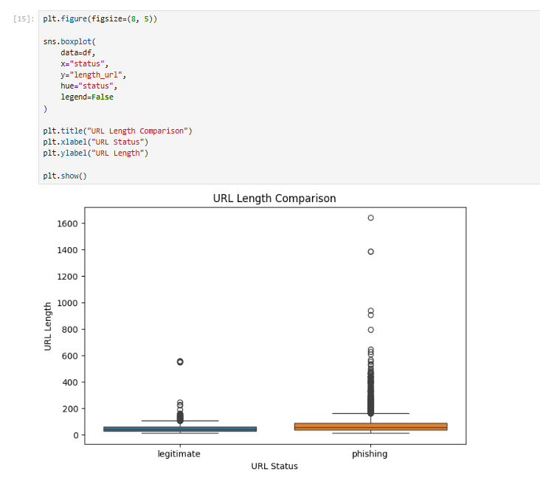

FREQUENCY DISTRIBUTION

- EMAIL-SMS

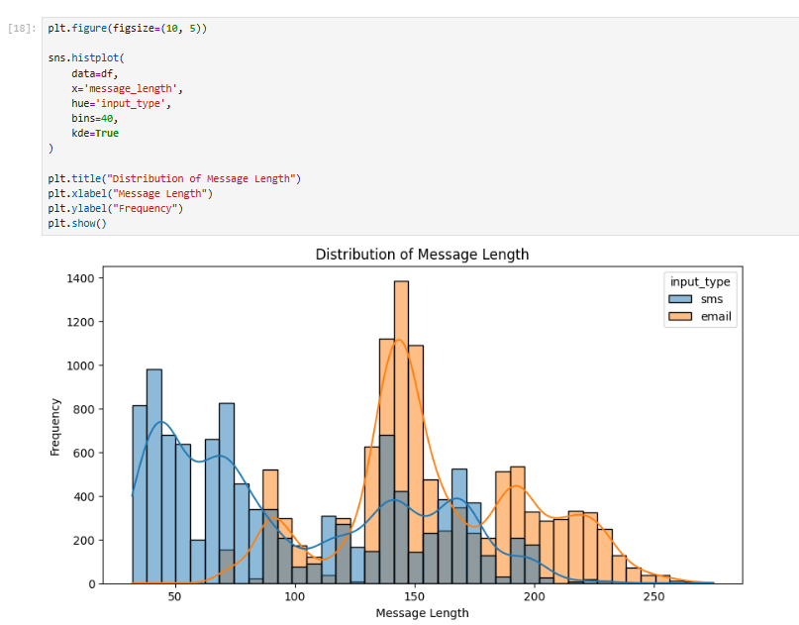

- URL
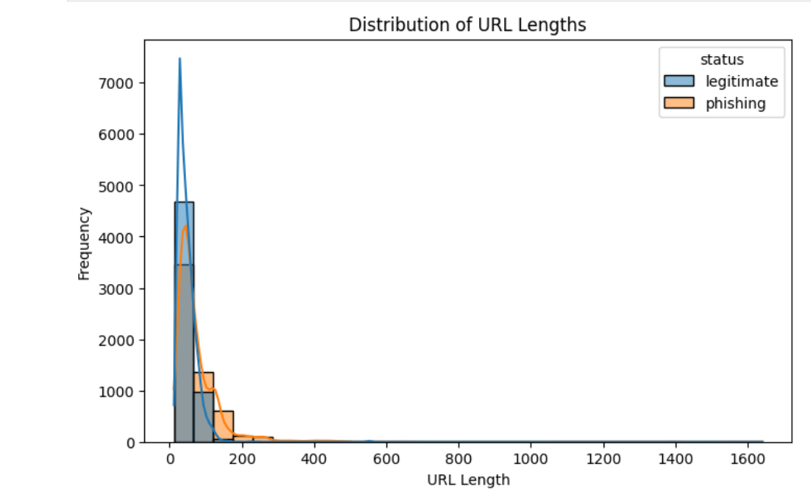

CONFUSION MATRIX

1.EMAIL-SMS

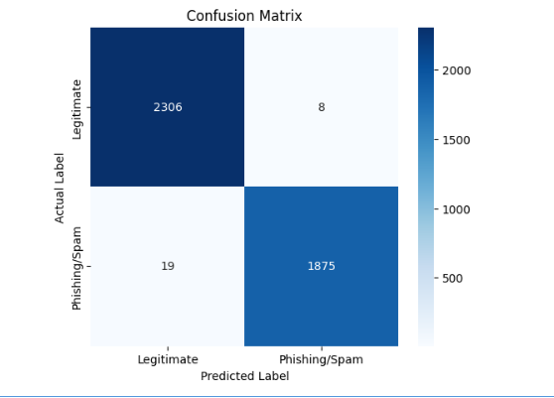

- URL
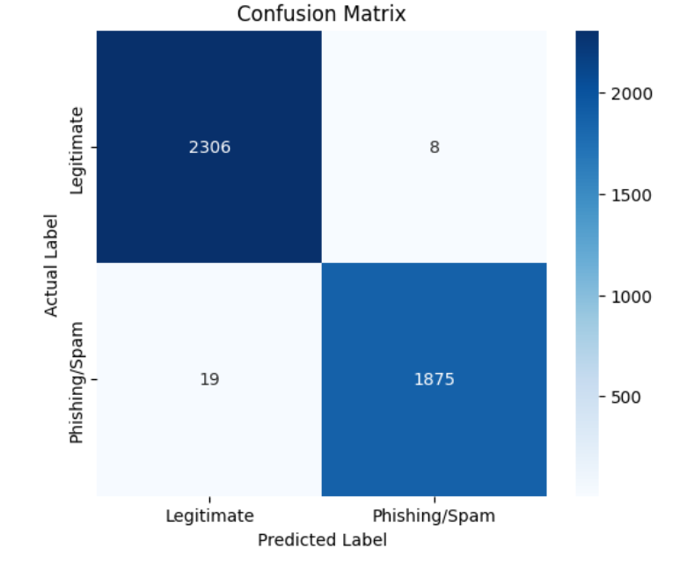

9. MODEL EVALUATION AND PERFORMANCE METRICS

9.1 Problem Type
The intended task is supervised classification. State whether each dataset uses binary or multiclass labels after inspecting the verified target column. Do not treat SMS spam as confirmed phishing without supporting labels.

9.2 Metrics
Accuracy is the fraction of correct predictions. Precision measures how many predicted positives are truly positive. Recall measures how many actual positives are detected. F1-score is the harmonic mean of precision and recall. ROC-AUC measures ranking discrimination when suitable class probabilities or scores are available.

9.3 Train-Test Split and Confusion Matrix
Use a documented train/test split, preferably stratified when appropriate. Generate a labelled confusion matrix for each model and discuss true positives, true negatives, false positives and false negatives.

9.4 Results
Model | Accuracy | Precision | Recall | F1 | ROC-AUC
Random Forest | 99.3% | 99.58% | 99.00% | 99.29% | N/A
Model 2
Model 3

10. MODEL BUILDING

Implement any three algorithms permitted by the guideline. A practical classification choice is K-Nearest Neighbours (KNN), Naive Bayes and Decision Tree. If SVM is chosen instead, document its settings and preprocessing. Linear Regression is not a standard classification algorithm.

10.1 K-Nearest Neighbours (KNN)
KNN predicts a class using nearby training observations. Scaling is generally important because distance calculations depend on feature magnitudes.

10.2 Naive Bayes
Naive Bayes is a probabilistic classifier based on Bayes' theorem. Select a variant suitable for the data representation; Multinomial Naive Bayes is commonly used with non-negative text features.

10.3 Decision Tree
A Decision Tree learns feature-based splits and can model non-linear relationships. Control tree complexity to reduce overfitting.

10.4 Training, Tuning and Comparison
Train and test all models using the same split protocol. Perform basic hyperparameter tuning using cross-validation on training data. Compare the held-out results and justify the best model using the project's priority, such as phishing-class recall while monitoring false positives.

11. ADVANCED TECHNIQUES AND PATTERN DISCOVERY

The guideline requires implementation of at least one of K-Means, DBSCAN or Apriori. The selected method must be executed on suitable data, visualized and interpreted. The section below is a plan until actual outputs are inserted.

11.1 Selected Technique — K-Means (Proposed)
K-Means groups numerical feature vectors into K clusters by assigning observations to the nearest centroid. Scale suitable features and justify K using evidence such as an elbow plot or silhouette score. If text features are used, document the vectorization and any dimensionality reduction.

11.2 Cluster / Pattern Visualization

11.3 Interpretation

12. CONCLUSION & FUTURE WORK

12.1 Conclusion
VEIL presents an academic approach to analysing suspicious content across URLs, emails and SMS. The use of a separate URL pipeline and a combined email/SMS text pipeline reflects the different structures of these inputs. The final conclusion must be based on verified datasets and actual preprocessing, EDA, model evaluation and advanced-technique results.

12.2 Limitations
- The currently available email/SMS examples are synthetic and must be replaced for the real-dataset requirement.
- The URL workbook's original provenance and exact unique sample count must be verified.
- SMS spam and phishing are not interchangeable labels.
- Class imbalance, duplicates, data leakage and dataset bias may affect performance.

12.3 Future Work
- Use verified, licensed public datasets and preserve source attribution.
- Evaluate on independent and more recent data.
- Improve explainability and error analysis.
- Build a user interface routing each input type to its appropriate model.

13. BIBLIOGRAPHY

- Cybersecurity and Infrastructure Security Agency (CISA). Recognize and Report Phishing. Available at: https://www.cisa.gov/secure-our-world/recognize-and-report-phishing
- National Institute of Standards and Technology (NIST). Cybersecurity Guidance. Available at: https://www.nist.gov/cybersecurity
- Scikit-learn Developers. Scikit-learn: Machine Learning in Python. Available at: https://scikit-learn.org/stable/
- Pandas Development Team. Pandas Documentation. Available at: https://pandas.pydata.org/docs/
- Matplotlib Development Team. Matplotlib Documentation. Available at: https://matplotlib.org/stable/
- Seaborn Development Team. Seaborn Documentation. Available at: https://seaborn.pydata.org/
- Python Software Foundation. Python Documentation. Available at: https://docs.python.org/3/
- Gujarat University. Bachelor of Computer Applications (BCA) Project Guidelines.
- Dataset sources: The original sources of the URL, email and SMS datasets used in the VEIL project.

